**ASSIGNMENT NO. 04**

**Name – Atharva Shivaji Jadhav Roll Number - DXC262AB12035**

**Batch – Dxc-262-Analytics-B12-Azure Company – DXC Technology**

**Employee Domain –Azure Analytics Training Under – Manipal Pro Learn**

**Trainer Name – Mr. Ajay Kumar**

**Case 33:** From the following table, write a SQL query to find those employees of department id 3001 or 1001

and joined in the year 1991. Return complete information about the employees

SELECT * FROM globetechtb231 WHERE to_char(HIRE_DATE,'YYYY')='1991'

AND (dep_id =3001 OR dep_id =1001) ;

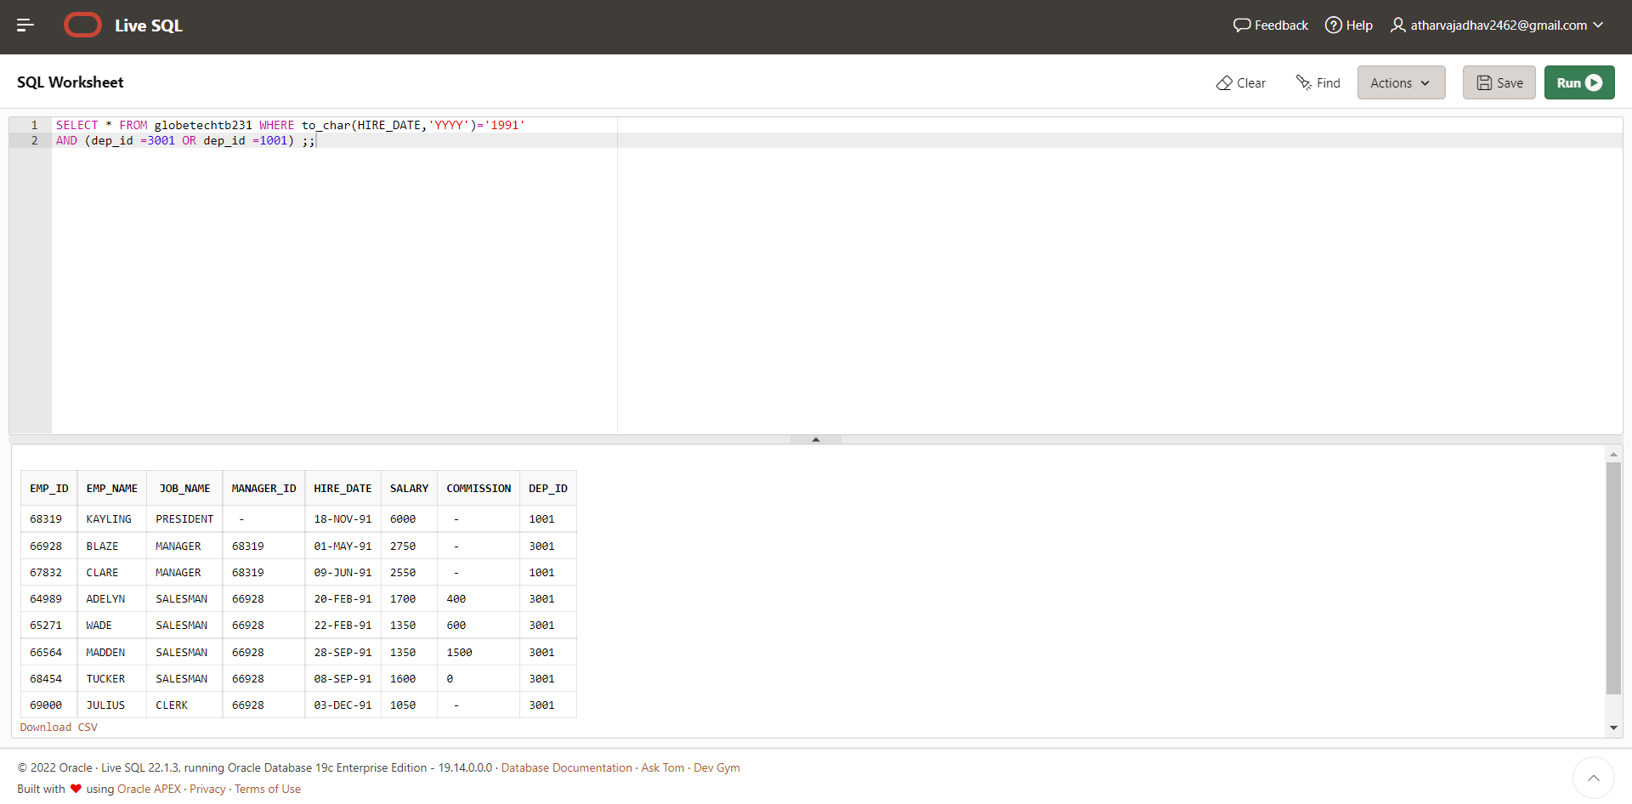

**CASE 35: From the following table, write a SQL query to find those employees whose designation is ‘CLERK’ and work in the department ID 2001.**

**Return complete information about the employees.**

**Case 34:** the following table, write a SQL query to find those employees who are working for the department ID 1001 or 2001.

Return complete information about the employees

**SELECT * FROM globetechtb231 WHERE (dep_id =1001 OR dep_id =2001) ;**

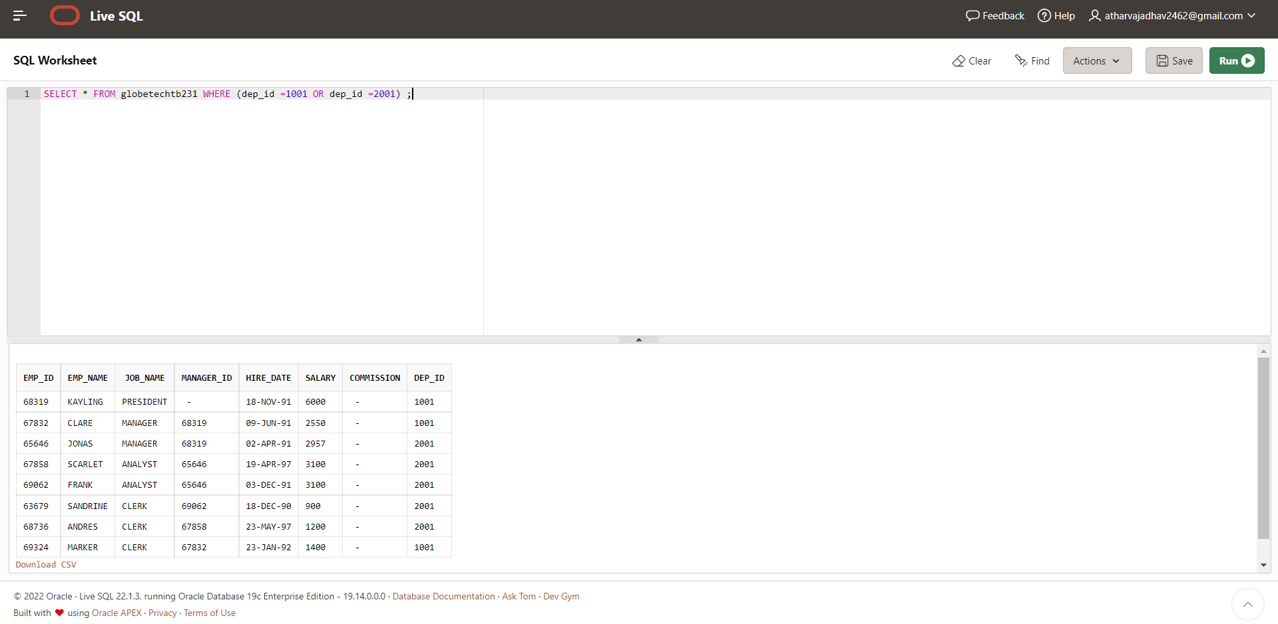

**CASE 35:** From the following table, write a SQL query to find those employees whose designation is ‘CLERK’ and work in the department ID 2001.

Return complete information about the employees.

**SELECT * FROM globetechtb231 WHERE (job_name = 'CLERK' AND dep_id =2001) ;**

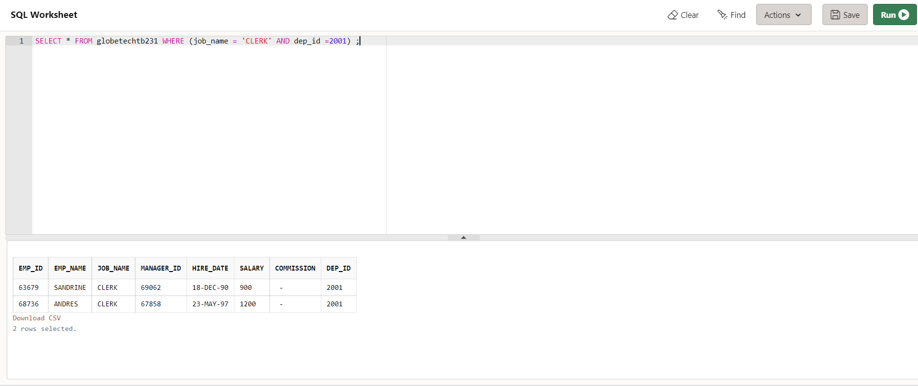

**CASE 36:**From the following table, write a SQL query to find those employees who are either CLERK or MANAGER.

Return complete information about the employees

**SELECT * FROM globetechtb231 WHERE (job_name = 'CLERK' or job_name ='MANAGER') ;**

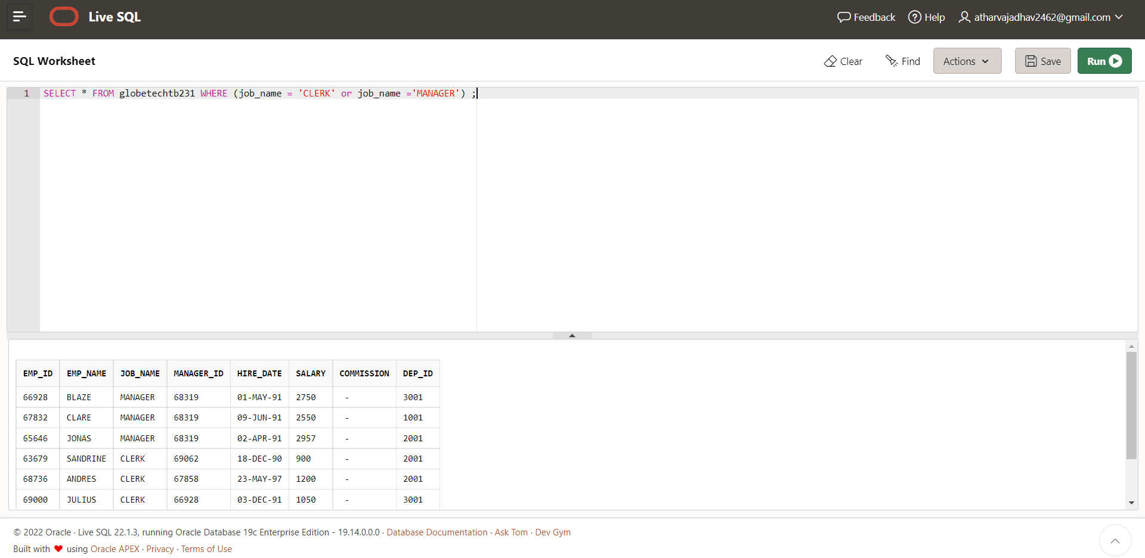

**CASE 37**:From the following table, write a SQL query to find those employees who joined in any year except the month of February.

Return complete information about the employees

**SELECT * FROM globetechtb231 WHERE to_char(hire_date,'MON') NOT IN ('FEB');**

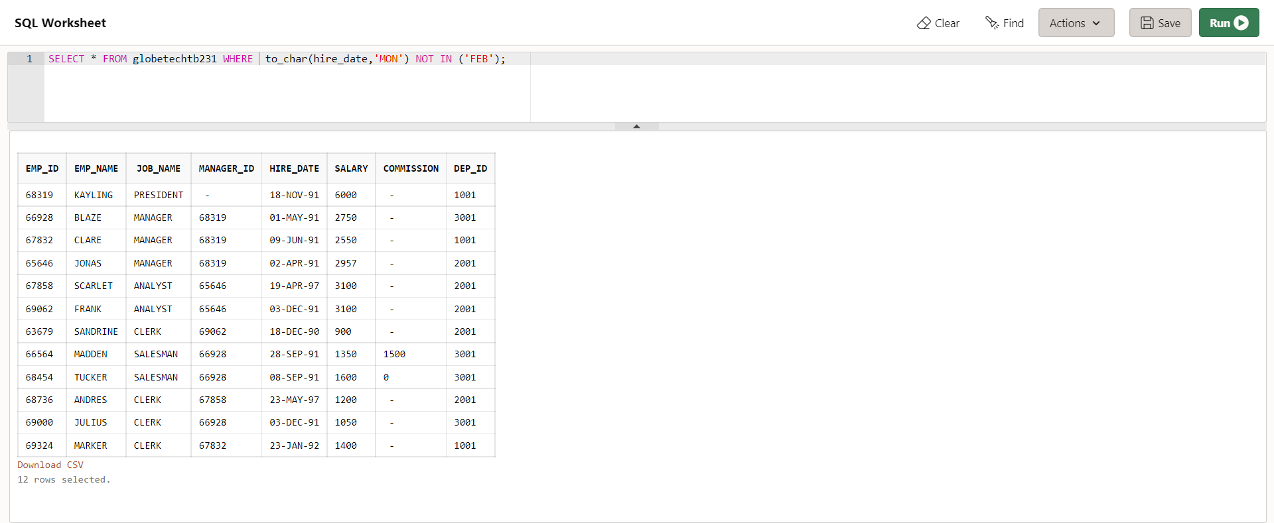

**CASE 38**:From the following table, write a SQL query to find those employees who joined in the year 91.

Return complete information about the employees

**SELECT * FROM globetechtb231**

**WHERE to_char(hire_date,'YYYY') = '1991';**

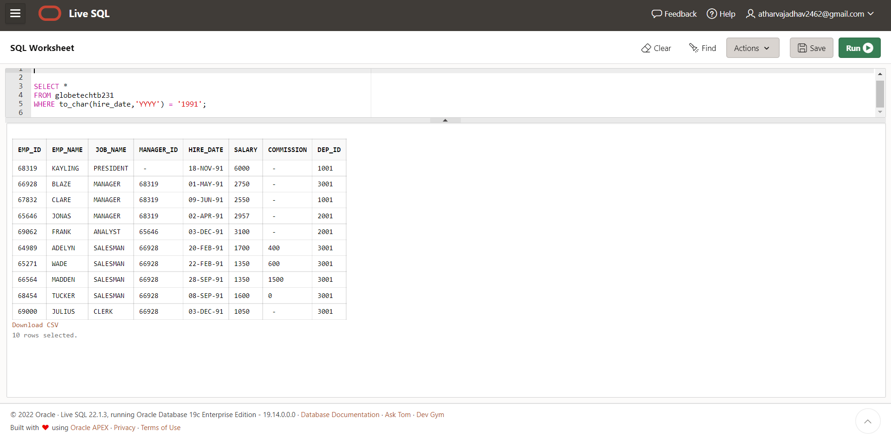

**CASE 39:**From the following table, write a SQL query to find those employees who joined in the month of June 1991.

Return complete information about the employees

**SELECT * FROM globetechtb231**

**WHERE to_char(hire_date,'mon-yyyy')='jun-1991'**

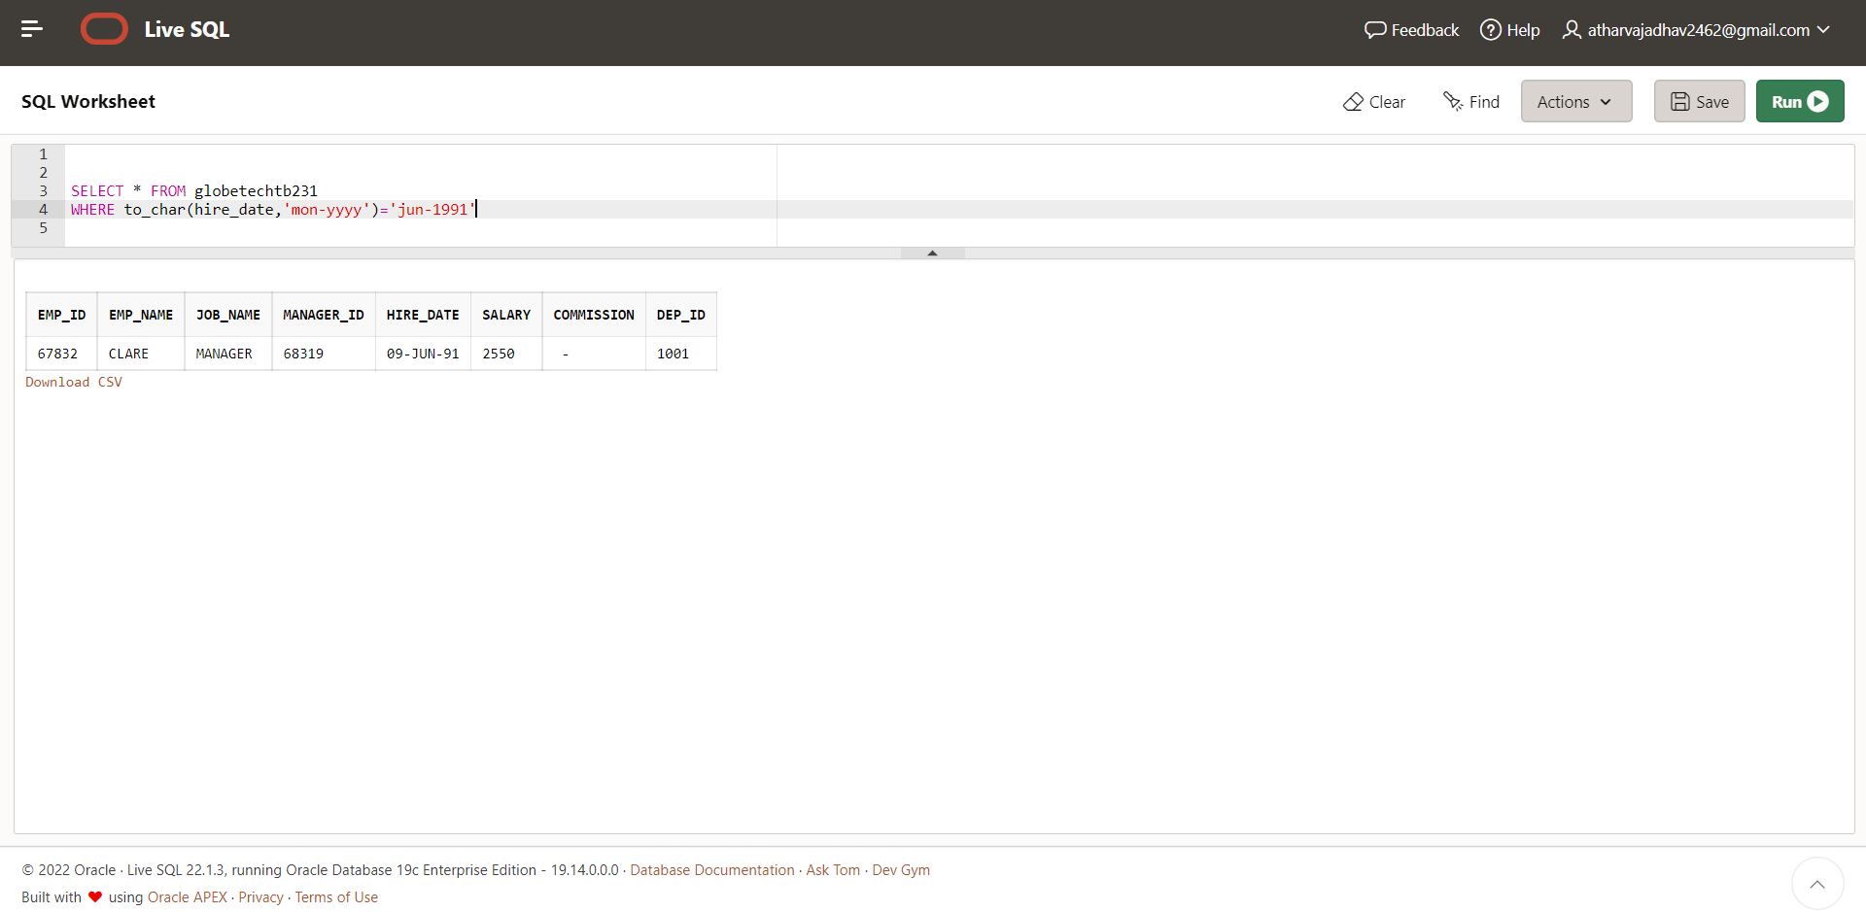

**CASE 40**: From the following table, write a SQL query to find all the employees whose annual salary is

within the range 24000 and 50000 (Begin and end values are included.). Return complete information about the employees.

**SELECT *FROM globetechtb231**

**WHERE 12*salary BETWEEN 24000 AND 50000;** 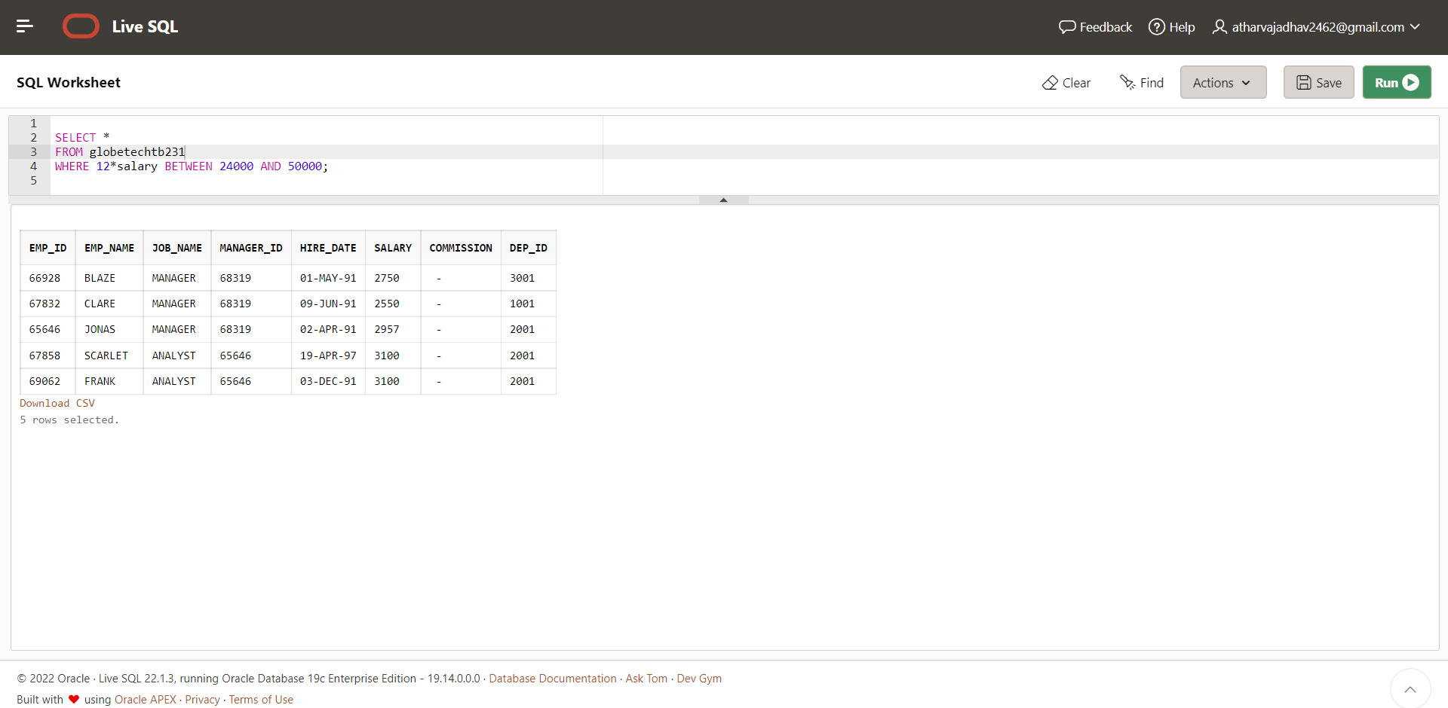

**CASE 41:**From the following table, write a SQL query to find all those employees who have joined on 1st May, 20th Feb, and 3rd Dec in the year 1991.

Return complete information about the employees.

**SELECT * FROM globetechtb231**

**WHERE to_char(hire_date,'DD-MON-YY') IN ('01-MAY-91', '20-FEB-91','03-DEC-91');**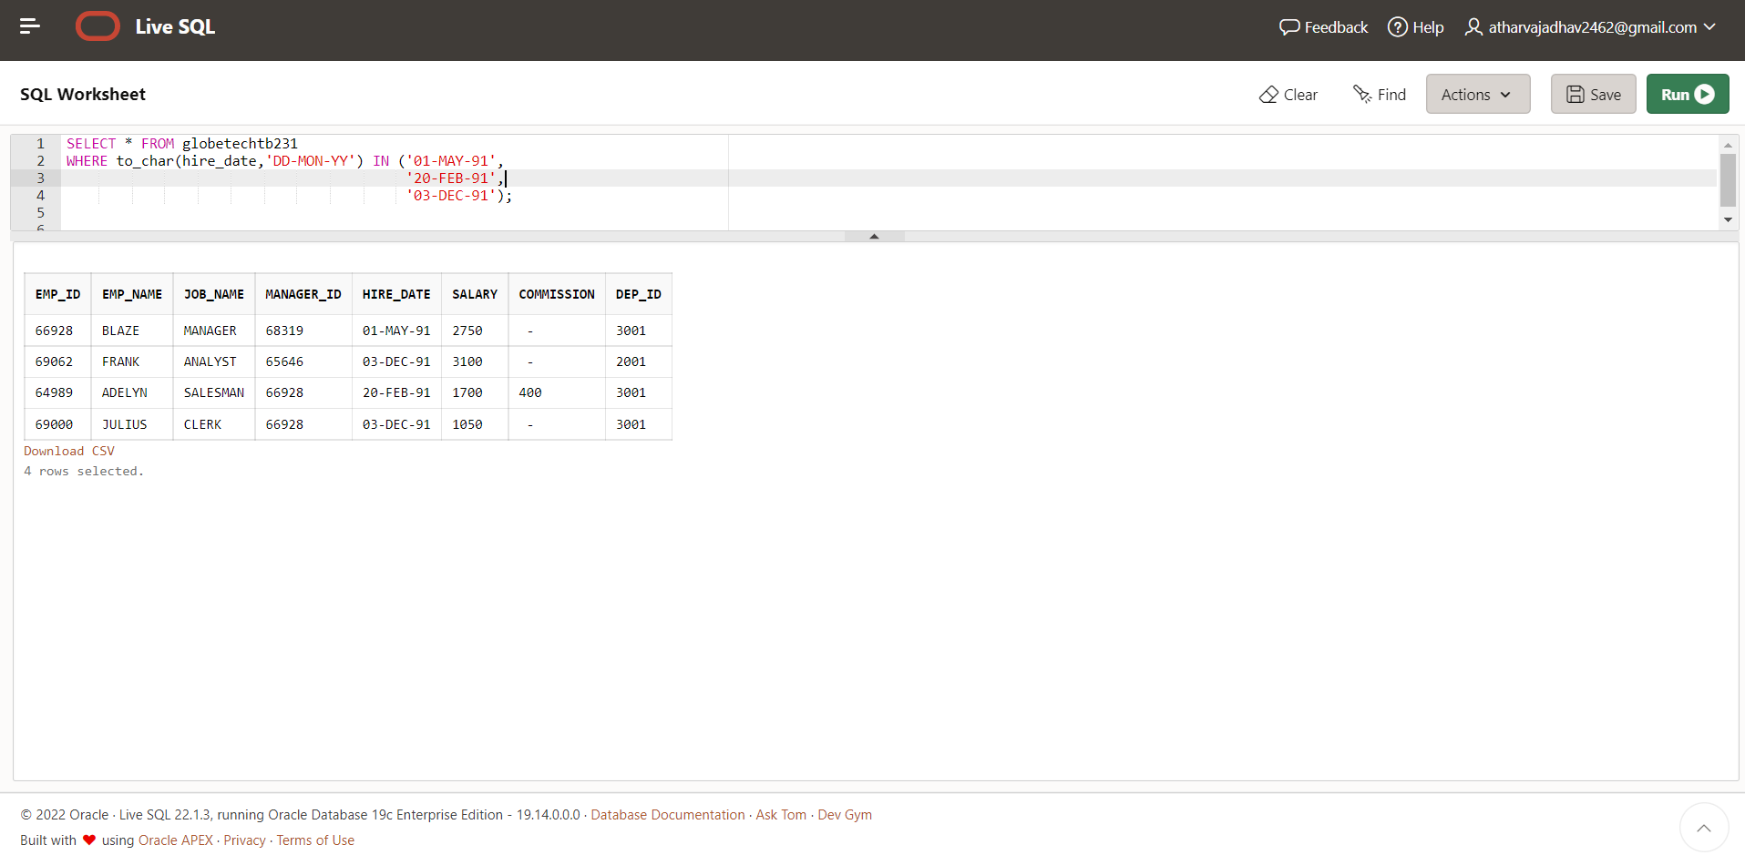

**CASE 42:**From the following table, write a SQL query to find those employees working under the managers 63679 or 68319 or 66564 or 69000.

Return complete information about the employees

**SELECT *FROM globetechtb231**

**WHERE manager_id IN (63679,68319, 66564,69000);**

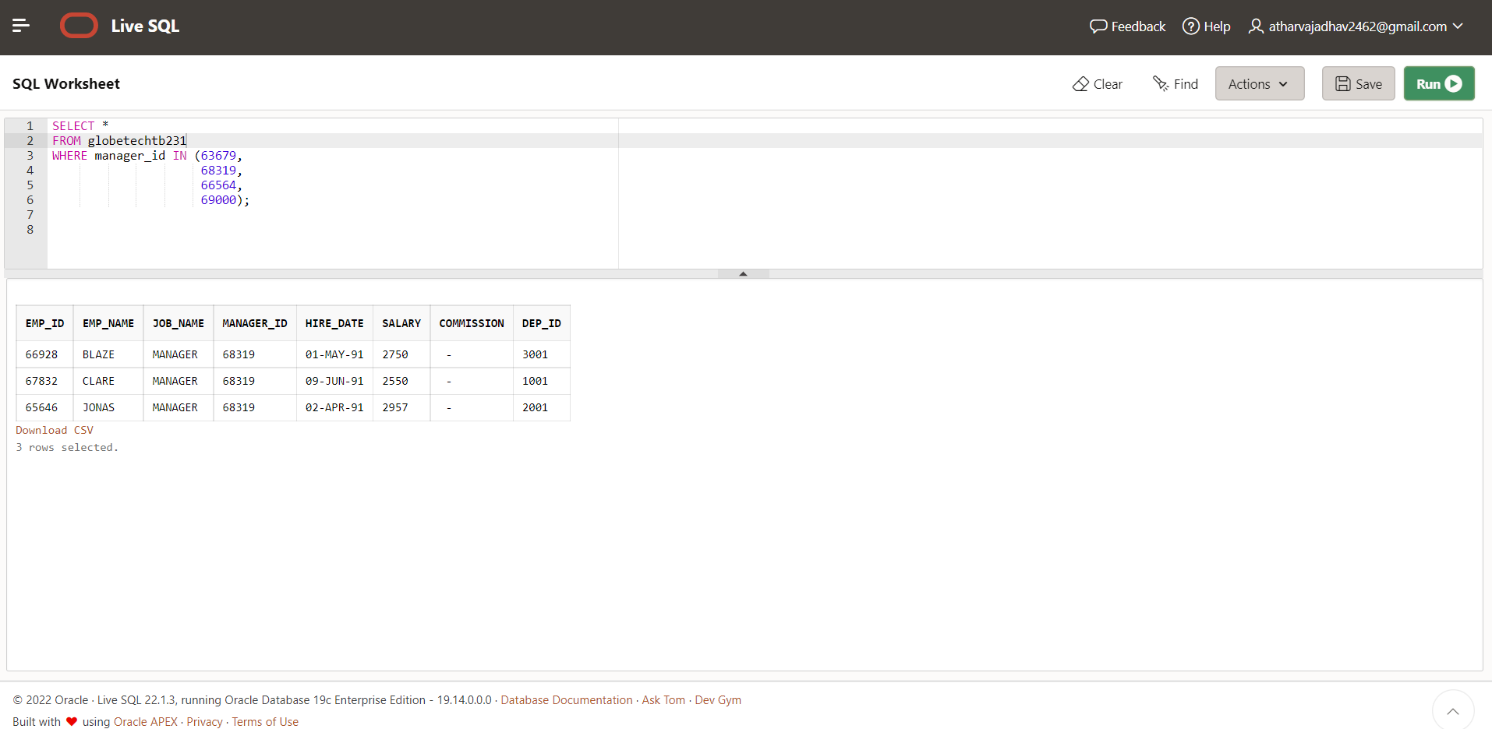

**CASE 43:**From the following table, write a SQL query to find those employees who joined after the month JUNE in the year 1991

and within this year. Return complete information about the employees

**SELECT * FROM globetechtb231**

**WHERE to_char(hire_date,'mon-yyyy')='jun-1991';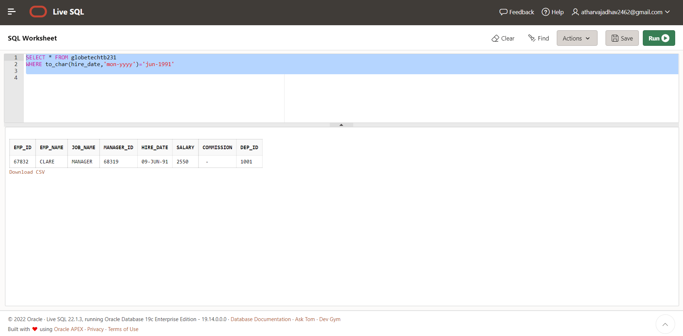case 44:**From the following table, write a SQL query to find those employees who joined in 90's.

Return complete information about the employees

**SELECT *FROM globetechtb231**

**WHERE to_char(hire_date,'YY') BETWEEN '90' AND '99';** 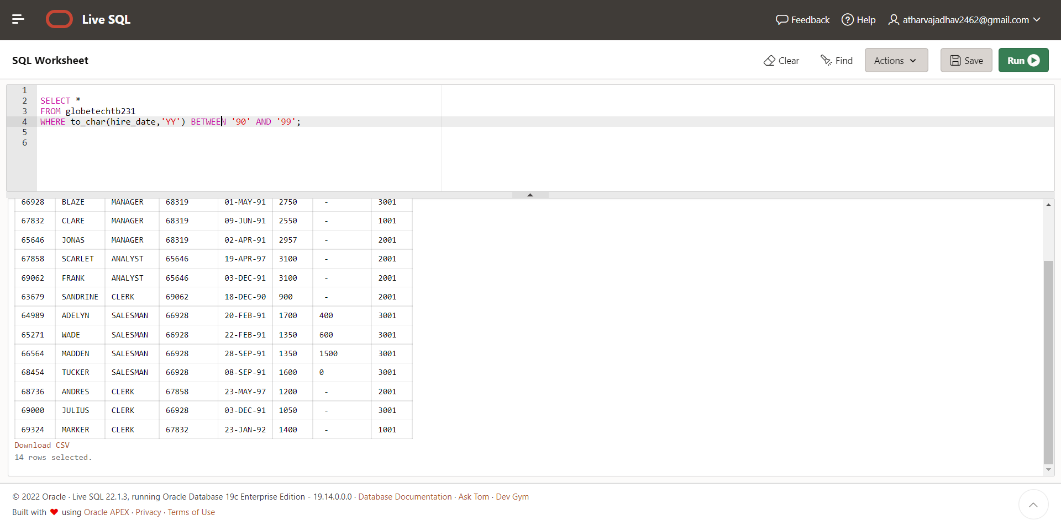

**CASE 45:** From the following table, write a SQL query to find those managers who are in the department 1001 or 2001.

Return complete information about the employees.

**SELECT * FROM globetechtb231**

**WHERE job_name = 'MANAGER' AND (dep_id = 1001 OR dep_id =2001);**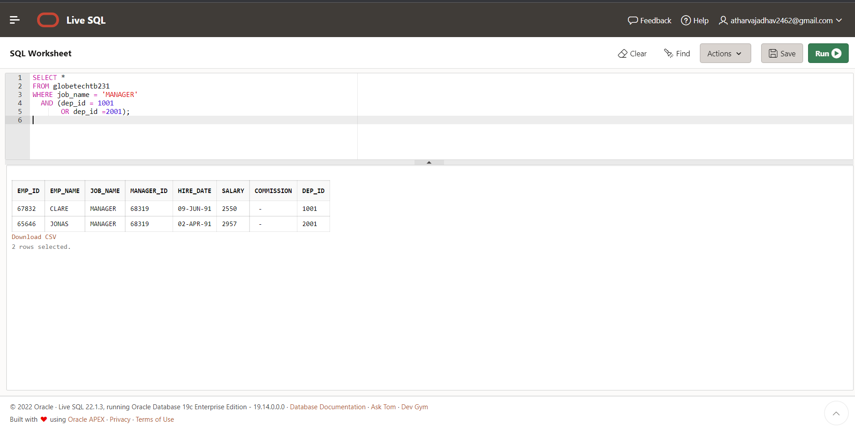

**CASE 46:** From the following table, write a SQL query to find those employees who joined in the month FEBRUARY with a salary range

between 1001 to 2000 (Begin and end values are included.). Return complete information about the employees

**select * FROM globetechtb231**

**WHERE to_char(hire_date,'MON') = 'FEB'**

**AND salary BETWEEN 1000 AND 2000;**

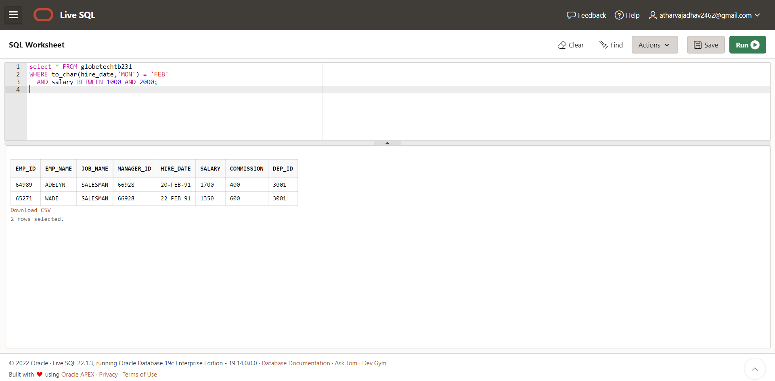

**CASE 47:** From the following table, write a SQL query to find those employees who joined before or after the year 1991.

Return complete information about the employees.

**SELECT *FROM globetechtb231**

**WHERE to_char(hire_date,'YYYY') NOT IN ('1991');**

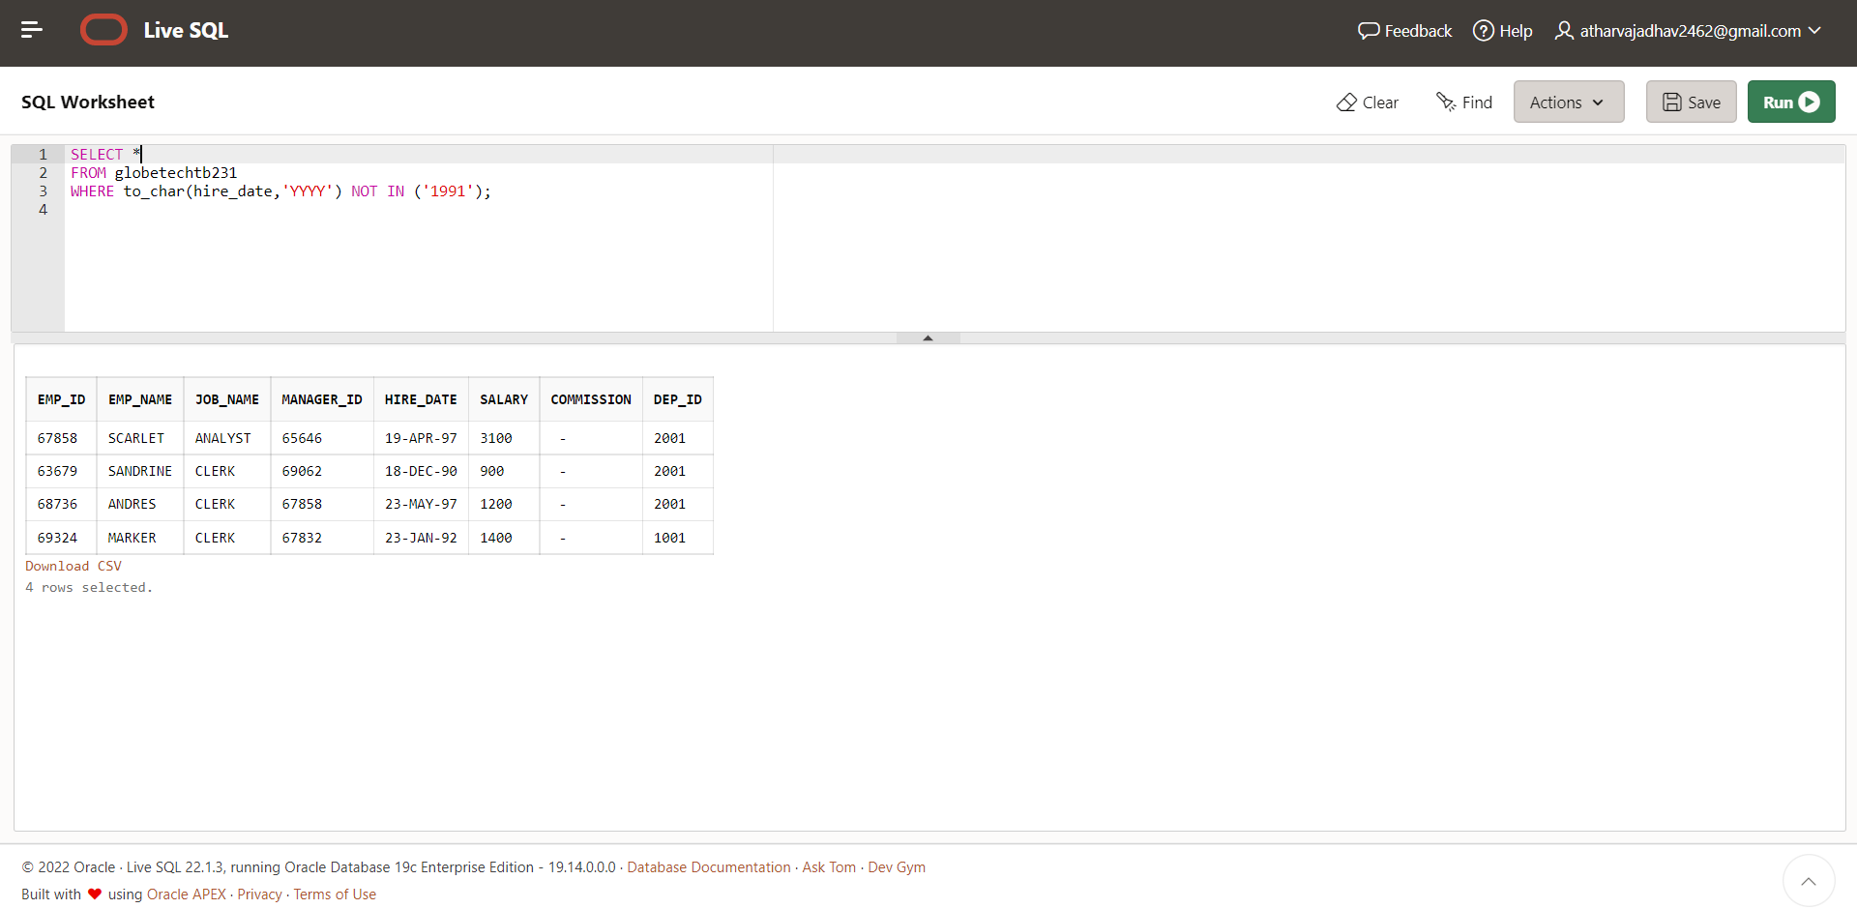

**CASE 48:**

**From the following table, write a SQL query to find employees along with**

**department name. Return employee ID, employee name, job name, manager**

**ID, hire date, salary, commission, department ID, and department name.**

**Query:**

**SELECT e.emp_id, e.emp_name, e.job_name,**

**e.manager_id,**

**e.hire_date,**

**e.salary,**

**e.commission,**

**e.dep_id,**

**d.dep_name**

**FROM globetechtb231 e, department d**

**WHERE e.dep_**

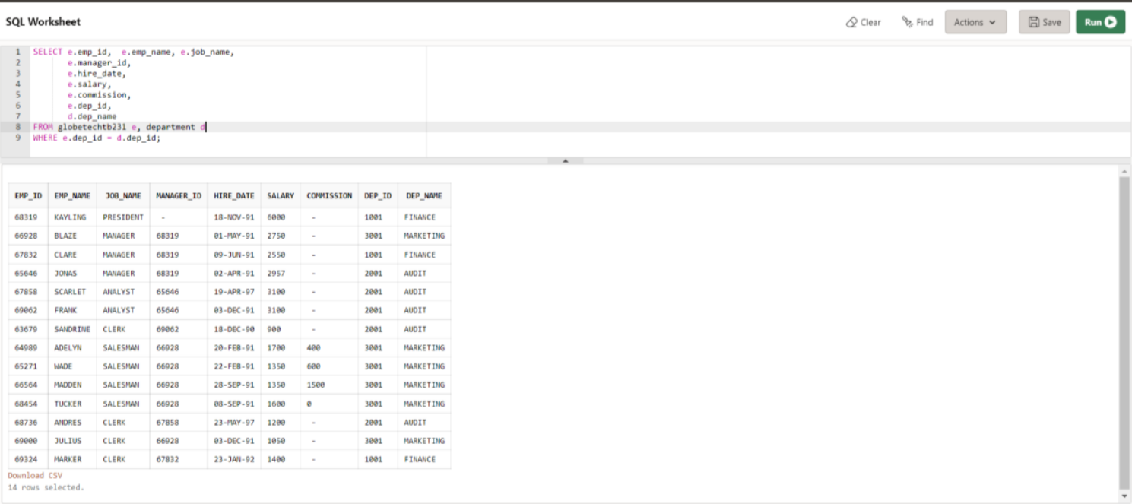

**Case 49:**

From the following tables, write a SQL query to find those employees who earn

60000 in a year or not working as an ANALYST. Return employee name, job

name, (12*salary) as Annual Salary, department ID, and grade.

**SELECT e.emp_name,**

**e.job_name,**

**(12*e.salary)"Annual Salary", e.dep_id, d.dep_name, s.grade**

**FROM globetechtb231 e, department d, salary_grade**

**s WHERE e.dep_id = d.dep_id AND e.salary**

**BETWEEN s.min_sal AND s.max_sal AND (((12*e.salary)>= 60000)**

**OR (e.job_name != 'ANALYST'))**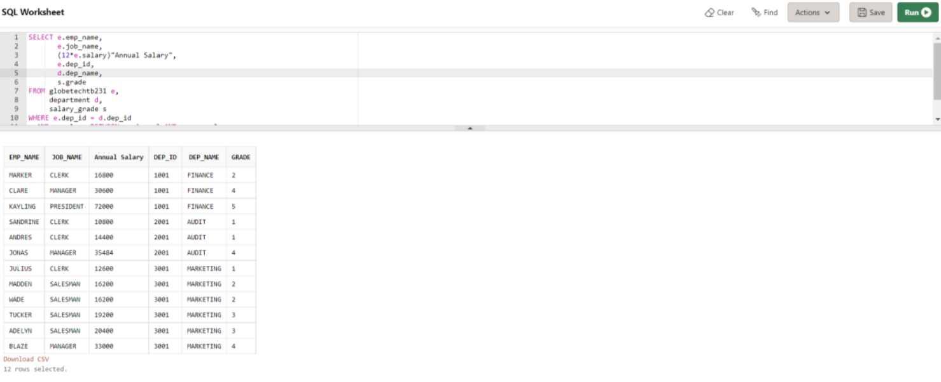

**CASE 50**:From the following table, write a SQL query to find those employees whose salary is higher than the salary of their managers.

Return employee name, job name, manager ID, salary, manager name, manager's salary.

**SELECT w.emp_name,**

**w.job_name,**

**w.manager_id,**

**w.salary,**

**m.emp_name "Manager",**

**m.emp_id,**

**m.salary "Manager_Salary"**

**FROM globetechtb231 w,**

**globetechtb231 m**

**WHERE w.manager_id = m.emp_id**

**AND w.salary > m.salary;**

